**TITLE: MULTIPROCESSOR DEMONSTRATION**

**PART OF CRICUIT**

**MAIN**

**ALU**

**REGISTER FILE**

**OR**

**XOR**

**AND**

**ADDER**

**4-BIT REGISTER**

**1-BIT REGISTER**

**1-BIT FULL ADDER**

* **MAIN CIRCUIT:**

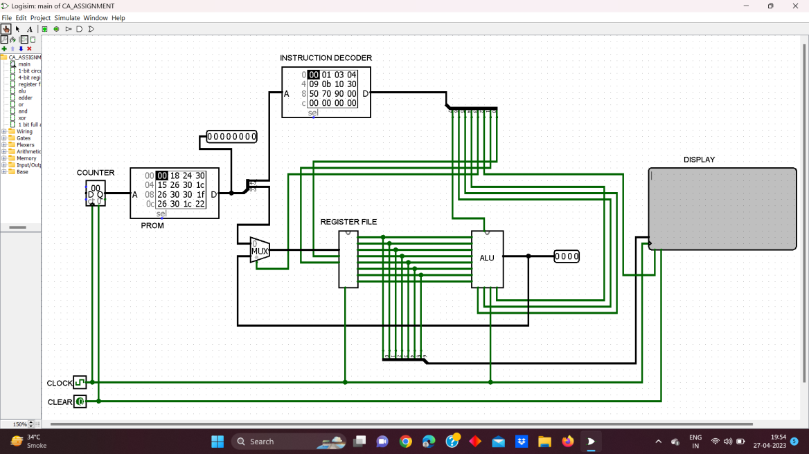

**This is a demonstrative CPU which can performs some Arithmetic and Logical Operation and print ascii text as per requirement. We Used PROM which has predefined instructions in it, along with instructional decoder which decodes instruction and executes instructions using register file and ALU**

* **REGISTER FILE**

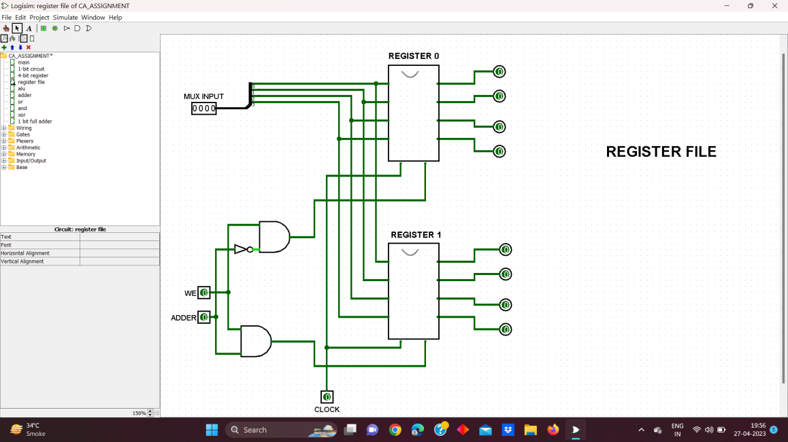

**It is a very small main memory unit which takes incoming operand and others results from ALU and Instructional Decoder it is 4-bit in size**

* **4-BIT REGISTER**

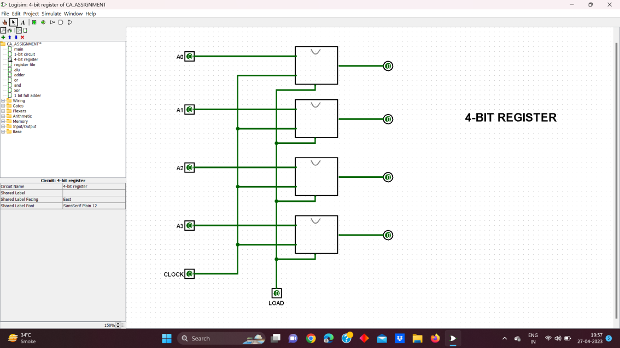

**It is a 4-bit register which was used in Register File as Main Memory sub-segment,A larger Register can be made by using more 1-bit regisers**

* **1-BIT REGISTER**

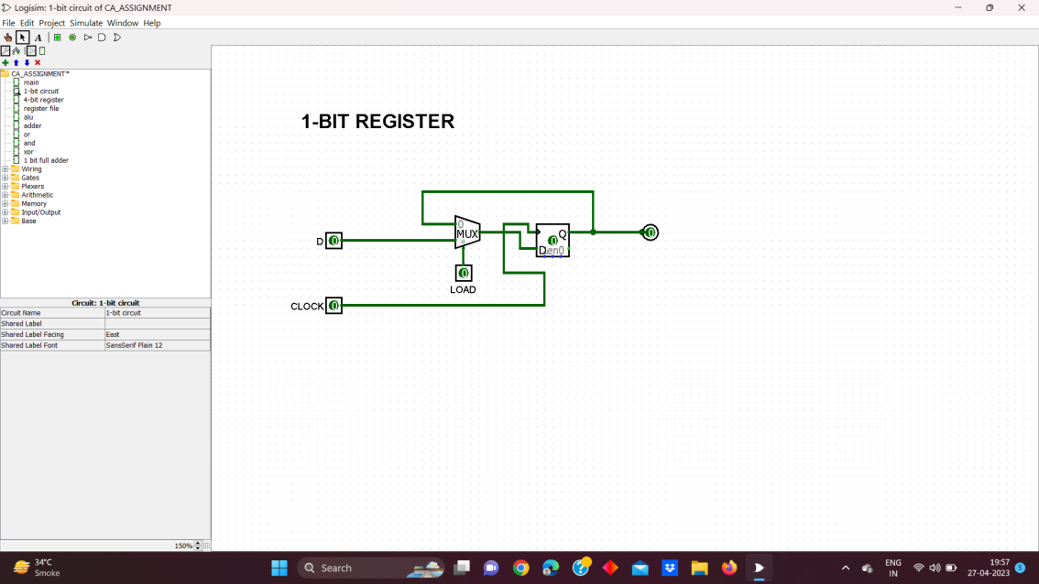

**It is a 1-bit register which is smallest unit of 4-bit register for storing 1-bit**

* **ARITHMETIC LOGIC UNIT(ALU)**

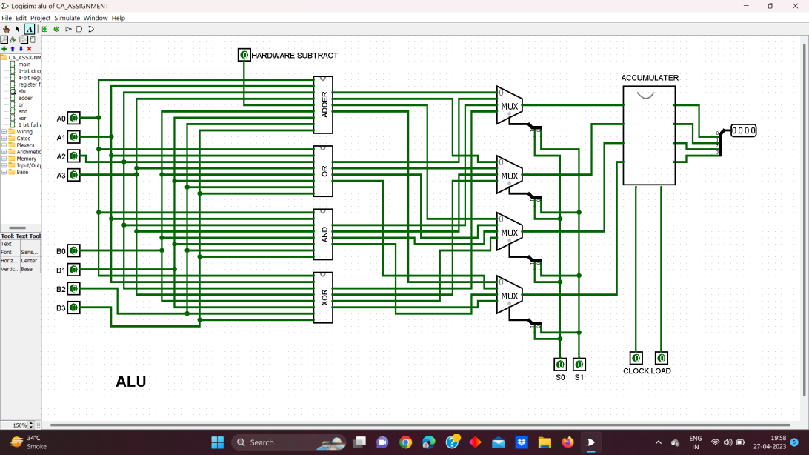

**This is Adder and Logic unit which perfromsArthimetic and Logical operations on given operands, it is one of main Systems in any CPU and Computing System. Here it consists of Subsegments mainly Adder, Logical or, Logical Andand Logical xor for 4-bit system**

* **ADDER**

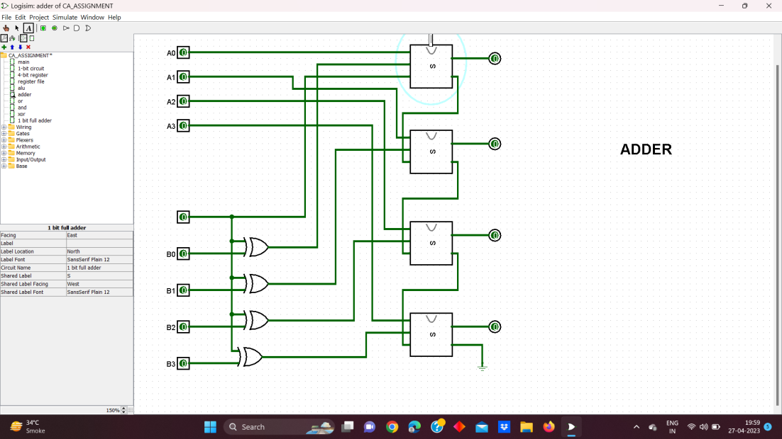

**This is Adder Section of ALU which performs 4-bit system, it uses 1-bit full adder and such 4 adders are connected for simple addition, a bigger system can be easily implemented by just using more 1-bit adder**

* **1-BIT FULL ADDER**

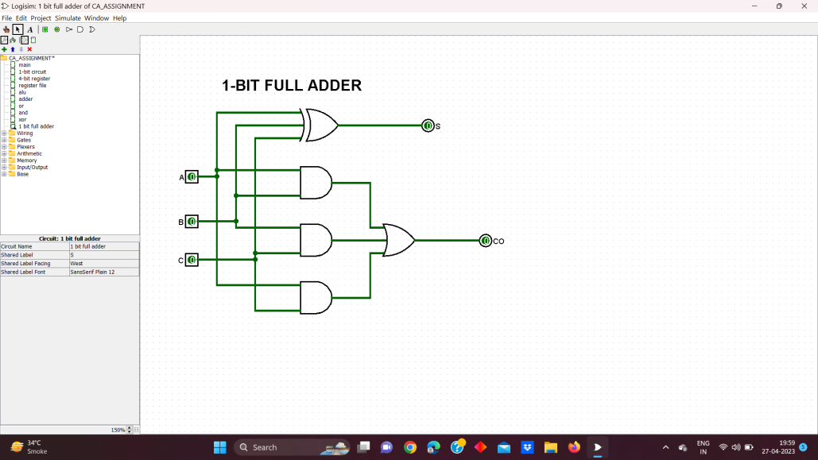

**It is one – bit simple adder which is smallest unit of 4-bit adder**

* **OR**

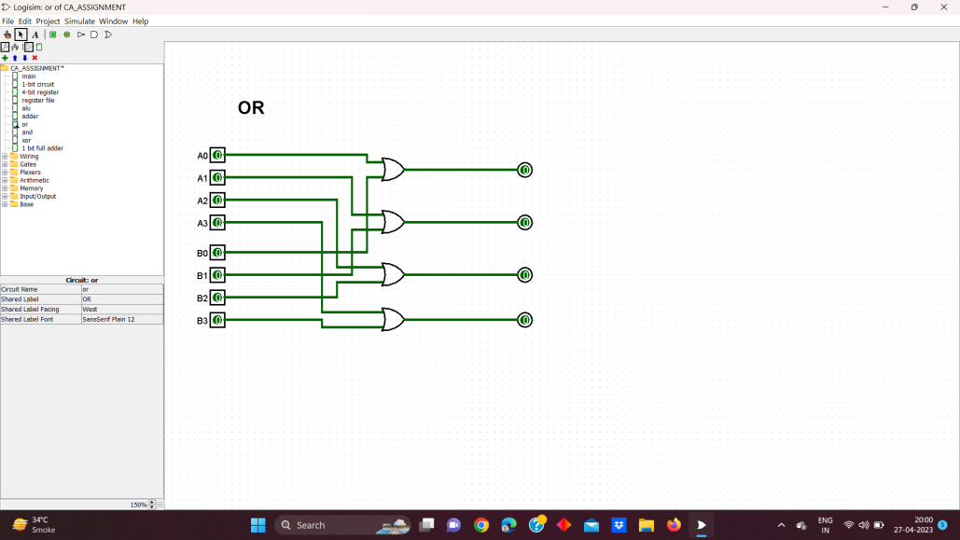

**This is 4-bit Logical or subunit of ALU which performs or operation**

* **AND**

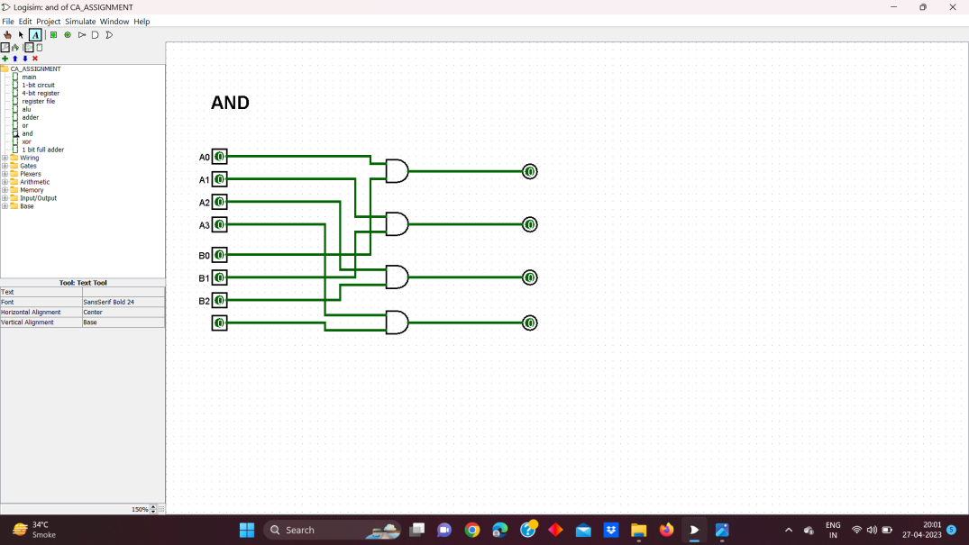

**This is 4-bit Logical AND subunit of ALU which performs and operation**

* **XOR**

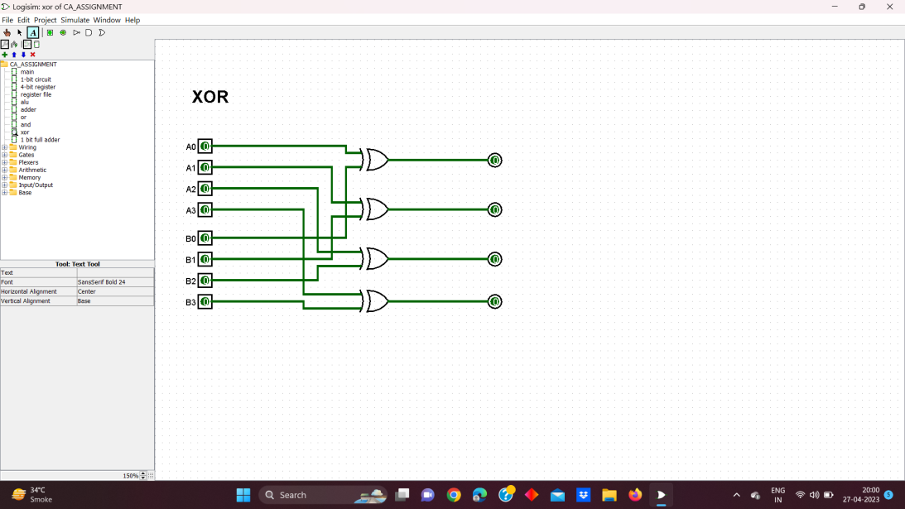

**This is 4-bit Logical XOR subunit of ALU which performs xor operation**

* **ASCII CODE FOR INSTRUCTION:**

|  |  |
| --- | --- |
| 23 | Print Integer |
| 24 | Print Capital Alphabet |
| 26 | Print Small Alphabet |
| 22 | Print Special Character |
| 30 | Display Output |
| 13 23 30 | Print integer 3 in Display |
| 13 24 30 | Print Small **a** in Display |
| 13 25 30 | Print Capital **A** in Display |
| 1a 20 30 | Enter a new Line |
| 1d 20 30 | Print a Space or = in display |

* **Advantages of Multiprocessor System**
* In a multiprocessor system, even if one processor fails, the system will not halt. This ability to continue working despite hardware failure is known as graceful degradation
* If multiple processors are working in tandem, then the throughput of the system increases i.e. number of processes getting executed per unit of time increase.
* Multiprocessor systems are cheaper than single processor systems in the long run because they share the data storage, peripheral devices, power supplies etc.
* **Disadvantages of Multiprocessor system**
* There are multiple processors in a multiprocessor system that share peripherals, memory etc. So, it is much more complicated to schedule processes and impart resources to processes. Than in single processor systems. Hence, a more complex and complicated operating system is required in multiprocessor systems.
* All the processors in the multiprocessor system share the memory. So a much larger pool of memory is required as compared to single processor systems.